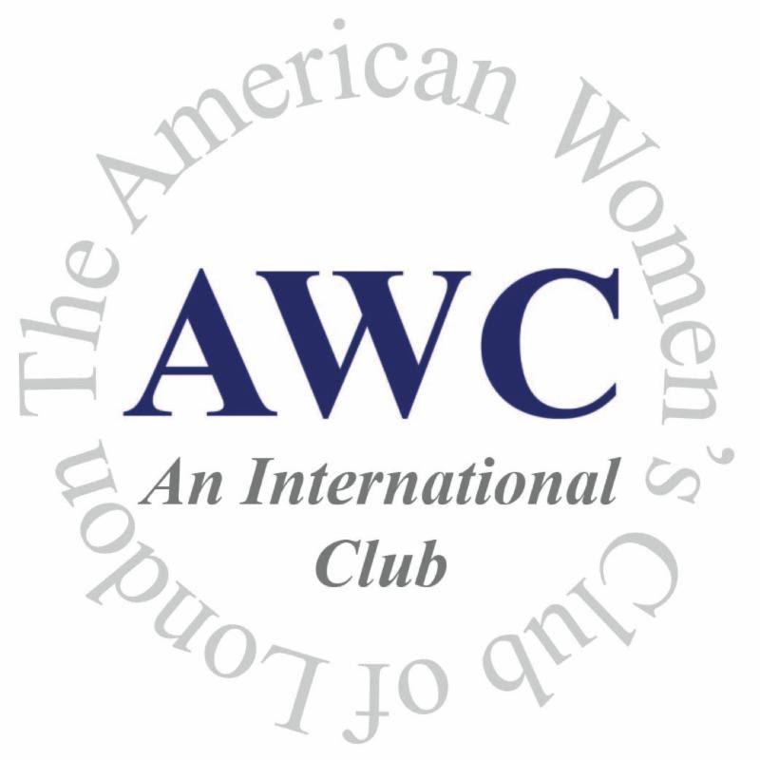
American Women’s Club of London

2018 Founders’ Day Silent Auction Donation Form

Donor Name or Business Contact:

Business Name:

Address:

Phone: Email:

Website address to be linked:

I would like to donate the following item(s) to the auction:

Please provide a description of donated auction item(s). Attach any information that will help sell your item and provide more information about your business, such as a brochure, menu, review/article, photograph, or other visual aid.

Item Description | # Donated | Estimated Value

Delivery of Items:

- My item/gift certificate accompanies form

- Please pick up item/gift certificate at this location:

- Please contact me to arrange delivery

I would like to also include a separate donation in the amount of £_________ (Please make checks out to ‘AWC London’)

I would like to be contacted about discounted advertising opportunities in the AWC weekly newsletter, reaching over 250 women every week. Yes ______ No _______

Please complete form, make a copy for your records, and submit to the American Women’s Club office using any of the above delivery methods. If you have any questions, please contact us at foundersday@awclondon.org

American Women’s Club Ltd. – Registered in England No. 552731
68 Old Brompton Road | London, SW7 3LQ | 020 7589 8292 | www.awclondon.org

